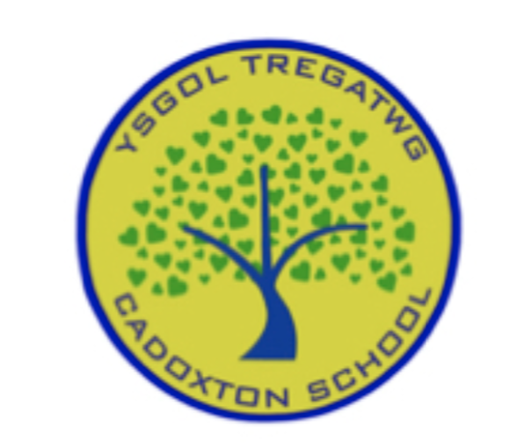Summary Plan for Re-opening Cadoxton Primary School - Covid-19
Last Reviewed 27th November 2020 - If you have any questions which you feel are not answered within this document, please contact Mrs Milton – MiltonR@hwbmail.net
Pupils Returning to School
- Children will continue to access a broad and balanced curriculum.
Uniform and Equipment
- All pupils will be expected to wear normal school uniform.
- Pay for uniform on Parent Pay. Any problems please email the school office. Purchased uniform will be sent home with your child as it arrives. No parents / Adults to access school office.
- Where possible, pupils should wear freshly laundered school uniform each day.
- Where possible, children should wear freshly laundered PE kit on their allocated PE days. Information of timetabled sessions to follow.
- From Reception through to Year 6 we ask that pupils bring one bag with a snack and water bottle. Snack will be available, payable half termly via Parent Pay. It will be prepared and taken to individual classes for those individuals who have requested it.
- Pupils in Year 3 to 6 are asked to bring their own pencil cases.
- Children’s learning experiences will continue within the indoor and outdoor environment. Allocated equipment and resources will only be used within Year group bubbles.
Masks and Hygiene
- Parents are asked to wear masks and adhere to 2 metre social distancing at drop off and pick-up times. Staff are also required to wear masks and adhere to 2m distancing.
- There is currently no expectation that pupils should wear face masks but they are welcome to do so if desired. Those wearing masks should be able to remove and retain masks safely in a plastic bag within their personal belongings.
- All staff will be required to wear PPE (face mask, apron, gloves) when attending to the personal needs of children.
- Children will be required to wash their hands (preferably with soap and water) on entry to the classroom, prior to eating, before and after visiting the toilet/blowing their nose and prior to going home at a minimum. Hand washing stations are available in every classroom.
- The ‘Catch it, bin it, kill it’ process will be shared with children on a regular basis to minimise the spread of germs, particularly as we enter the season of usual coughs and colds.
- All classes will have a lidded bin, children will be requested to put paper towels, tissues etc. into the bin which will be emptied on a daily basis.
- Hand-driers and water fountains will be out of use.
- All classrooms will be well ventilated – windows and internal doors open in line with safeguarding regulations.
- In nursery, surfaces and resources are cleaned / wiped down between am and pm session, at the end of the day and where appropriate between use. Where appropriate, resources have been duplicated and allocated to morning and afternoon groups, e.g. dressing up clothes.
- Cleaners will be on site every day 3.15-6.15 to ensure all areas are deep cleaned. In addition to this, nursery will be cleaned at lunchtime on a daily basis.
- Snacks and packed lunches will be eaten within the classroom and all rubbish or leftovers put back into children’s containers / bags provided and taken home. Surfaces will be wiped down prior to and following food being eaten. Hands will be washed prior to and following food being eaten.
- Children will only use toilets allocated to their year group bubbles. They will be reminded to pull the flush, close the seat and wash their hands. Staff will monitor the use of the toilets to ensure cleanliness is ensured, e.g. seats put down, surfaces wiped down and children following handwashing protocol.
- In the event of a toileting accident, you will be contacted and informed unless prior arrangements are in place.
- In nursery, parents will provide a change of clothes in the event of messy play incidents. Children will be changed with regard to prior arrangements with individual parents. Soiled clothing will be returned in children’s bags and parents informed at pick up time.
Entering and Leaving School
- No parents will be allowed onto the school grounds. If you need to speak to a member of staff please use Seesaw, EMAIL or call the school office on 01446 741518.
- Please keep to a minimum the number of people doing the school run and disperse from outside the site as quickly as possible for the safety of everyone.
- Where possible, please walk to school to limit traffic and support social distancing measures.
- There will be no access to the Sports Hall car park between 2.30pm and 3.30pm daily to ensure parents can socially distance and pick up their children safely.
- Any communication with staff should take place via Seesaw or by making contact with the office to ensure continued adherence to social distancing.
- On arrival and departure from school, pupils will be met at their allocated entrances by Teachers and support staff. Children will be directed to line up in designates spaces – distanced coloured spots on the playground. Parents are asked to wear masks and adhere to 2m social distancing measures. Staff will wear masks and adhere to 2m social distancing measures.
- All year groups to enter into school though the allocated gates, following the rainbow signs on the floor. This will ease congestion and aid social distancing between both Parents / Adults and pupils in different year group bubbles.
  - Nursery will continue to enter and leave via usual Entrance / Exit points, parents lining up along path and waiting to be met by staff to ensure social distancing.
  - Reception will enter via the back entrance, up the steps – please adhere to social distancing, waiting to travel up and down the stairs whilst being used by others going in the opposite direction.
  - Year 2 will enter through the Year 2 yard.
  - Year 1 will enter through the gate facing their classrooms.
  - Year 3 will go through the main gate on the playground.
  - Year 5 will go through the middle gate on the playground.
  - Year 4 will go through the left-hand side gate on the playground.
  - Year 6 will enter school via the main gate on the playground and will be collected from the Community Centre unless walking home by themselves. Please ensure you contact your child’s class teacher to inform them if you give your child permission to walk home alone.
- Please ensure siblings are dropped off at the correct entrance to avoid pupils from different Year group bubbles mixing together.
- As pupils are welcomed into school, staff will observe / question general health and wellbeing. Please inform a member of staff if your child is unwell.

Year Group Bubbles
- Children will be taught in their class groups of approx. 30 pupils. There will be two classes in each year group bubble.
- Each year group bubble will use allocated rooms, spaces and resources within the indoor and outdoor environment.
- Active breaks and lunchtimes will be staggered to enable children to remain in their year group bubbles.
- Where possible, children will be encouraged to socially distance 2 metres.
- Where possible, furniture arrangements in classes will support forward facing and side by side seating arrangements.
- Adults have been allocated to year group bubbles to ensure consistency for learners.
- Where possible, all adults will follow 2 metre social distancing guidance in classrooms, additional spaces and when moving around the school. Allocated spaces for planning and preparation has been organised for staff within Year group bubbles.
- There will be minimal movement around the school to avoid groups of pupils coming into contact with each other.
- Reception through to Year six pupils will use individual lockers or boxes for their personal belongs and coats.
- Please pay for snack via Parent Pay to avoid exchange of money with staff on a half termly basis. Snack will be delivered to each class in sealed containers which will then be cleaned as appropriate and re-used. Nursery children will be provided with snack and drink on individual plates and in glasses which will then be cleaned in the dishwasher prior to next use.
Lunches
- School dinners are payable via Parent Pay. All lunch times will be staggered to avoid year group bubbles coming together at any point. A period of time to eat then access the outdoor environment for physical activity has been planned.
  - Reception through to Year 2 will have lunch in the school hall where a one- way system and appropriate seating arrangements have been planned.
  - Year 3 through to Year 6 will have lunch in their classes. Hot meals will be provided in individual containers which will be served and collected by allocated lunch time staff.
  - In each case, a team of lunch time staff will prepare classes prior to and following lunch being eaten. This will include tables being wiped and cleaned as appropriate.
Teaching:
- Where possible, Adults will maintain a 2-metre social distance from all pupils and each other
- Staff will ensure all hygiene procedures are effectively carried out by their pupils.
- Teachers will continue to teach towards the requirements of the New Curriculum but will be mindful of the need for pupils to work independently and not in close contact groups.

PE
- Children will be asked to wear PE kit on their allocated PE days. Please ensure PE clothing is appropriate to the weather, e.g. wear leggings or joggers instead of short on a cold day.
- We will not be able to lend PE to children.
- When using the sport hall, the changing rooms and toilets will be closed and out of use.
- Resources will be allocated to different year group bubbles to avoid cross-contamination.

Wellbeing
- Wellbeing and Personal, Social and Emotional Education will continue to be our central focus.
Test, Trace and Protect Procedures

- In the event of individuals entering the school building who are not part of the recognised and consistent staff, e.g. delivery drivers, they will log their contact details in line with Test, Trace and Protect procedures.

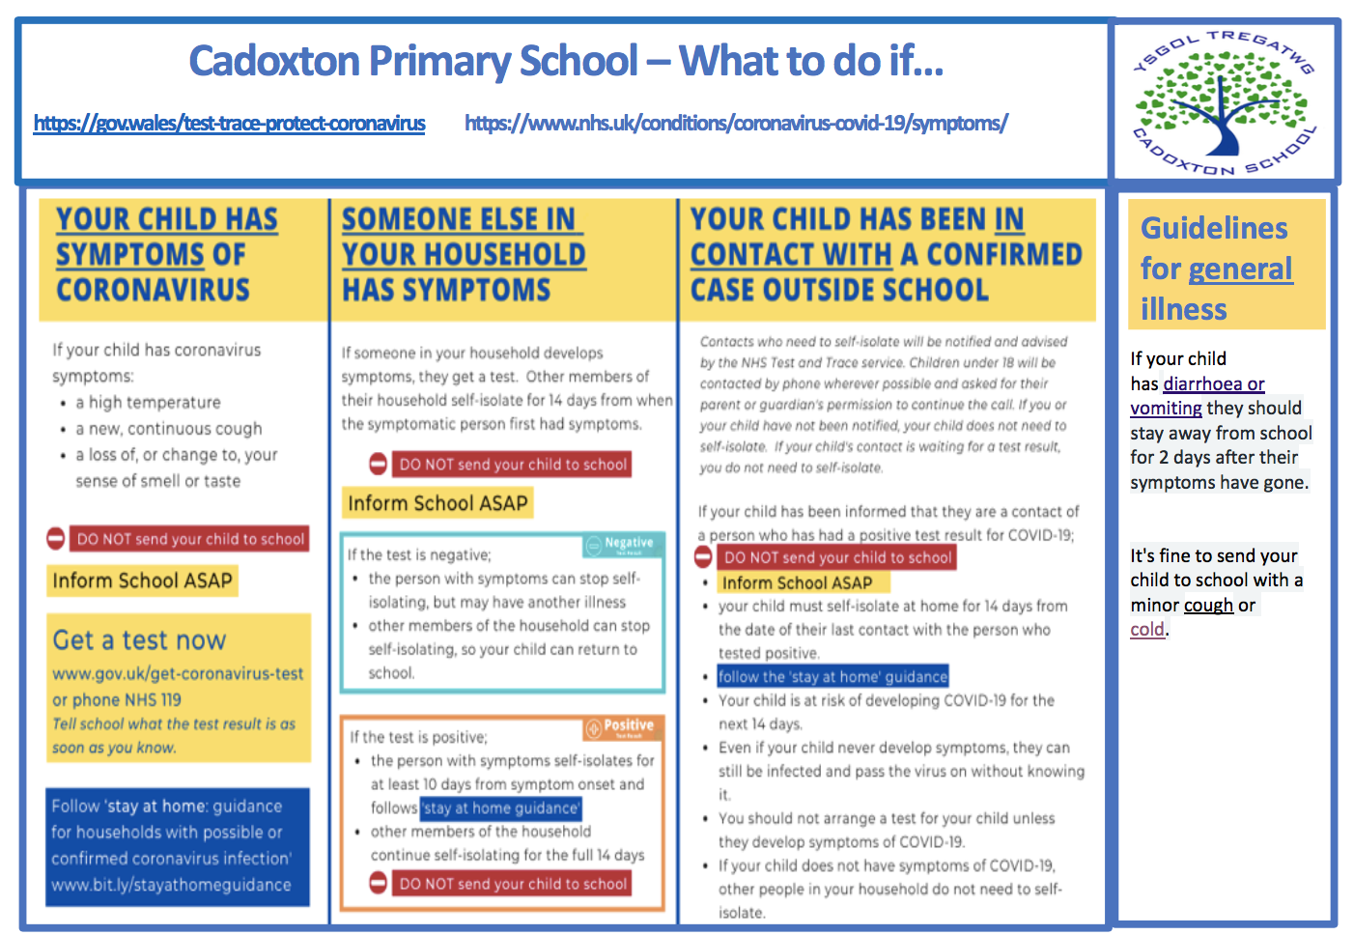
Our plan has been based on:
- https://gov.wales/sites/default/files/publications/2020-08/operational-guidance-for- schools-and-settings-from-the-autumn-term-version-2.pdf

