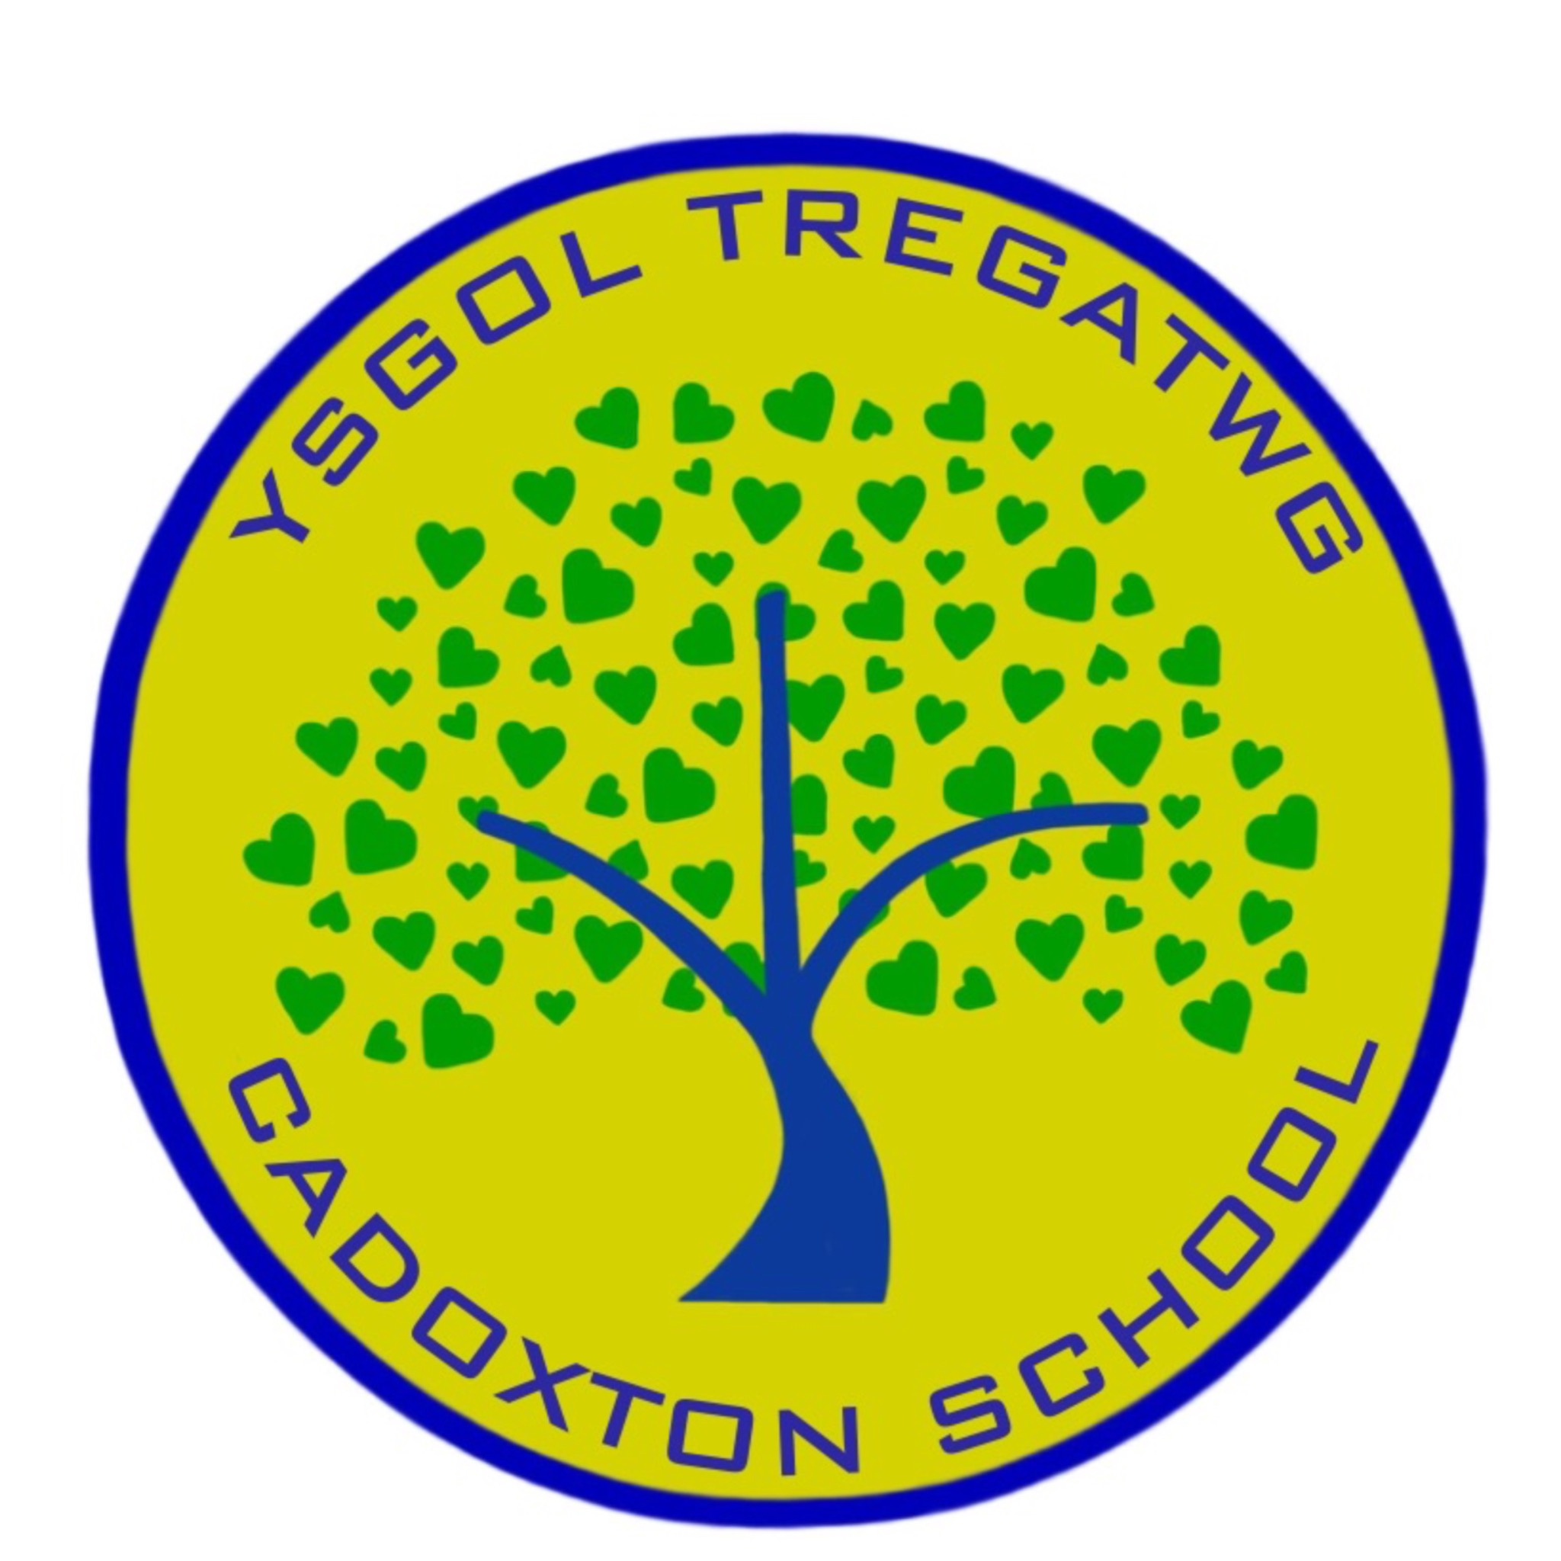

**GOVERNING BODY REPORT TO PARENTS,**

**DECEMBER 2022**

The Governing Body of Cadoxton Primary School is pleased to present their annual report to parents.

**Current Membership**

Mrs M Merrett Chair/Parent Governor until 11/9/26

Mrs J Hayward Executive Headteacher

Mrs R Milton Head of School

Miss H Cogbill Teacher Governor until 1/9/25

Mrs L Powell Non Teaching Governor until 1/9/25

Mr R Jones Minor Authority Representative until 11/11/24

Mrs R Nugent-Finn LEA Governor until 16/10/25

Cllr C Iannucci LEA Governor until 1/9/26

Mr Sean Murphy Co-opted Governor until 1/9/24

Mrs Wendy Thomas (Vice Chair) Co-opted Governor until 3/10/25

PSCO Dom Bury Co-opted Governor until 19/7/25

Mrs J Commrie Co-opted Governor until 26/10/23

Mrs C Harris Parent Governor until6/10/25

Ms E Hannah Parent Governor until 11/9/26

Clerk to Governors: Mrs Rachel Cox c/o School

**School Development Plan**

During March we conducted a thorough self-evaluation of all aspects of school life. Questionnaires were sent to parents and completed by children. Reviews of curriculum areas were conducted by teaching staff, and all staff reviewed the information as well as data trends, etc. All of this information was pulled together during an INSET day including Governors, members of the Parent Council and pupil Action Group leaders. As an outcome we identified a plan for ongoing development.

The Development Plan is illustrated here:

**The Curriculum and Provision for Additional Learning Needs**

The curriculum provided at Cadoxton Primary School isaligned to the ambition of Welsh Government’s “Successful Futures”, the new Curriculum for Wales which seeks to secure every child as:

1. An ambitious capable learner
2. A healthy, happy, confident individual
3. An ethical, informed citizen
4. A creative, enterprising contributor.

Cadoxton Primary School is seen to be innovative in its approach in achieving this for all children. Every learning experience seeks to achieve these aims, preparing our children to be “the very best they can be”. Cadoxton Primary is an inclusive school and staff strive to provide the children identified as having barriers to their learning, with a happy, supportive and fulfilling education that enables them to reach their potential as learners.

**Welsh**

The Welsh language is taught discretely, within lessons and the school day through incidental use. It is also promoted by our “Criw Cymraeg” action group. Last year, we were successful in achieving the Gold Standard “Siarter Iaith” in recognition of our excellent work with the Welsh language.

**Pupil Attendance**

Attendance figures for the academic year 21/22 were 91% which is lower than years prior to the COVID pandemic. This is in line with other schools in Wales due to a number of reasons. It is crucial that children attend every day if possible. We know this is how children thrive and can be the best they can be, we thank parents for working with us.

Where problems occur and attendance falls, we speak with parents. When attendance falls below 80% and there is no obvious reason, we work with the Vale of Glamorgan Educational Welfare Officers (EWO). Governors also review the policy for parents wishing to take their children on holiday during term time. Any parent wishing to do this should speak to Mrs Milton before booking a holiday. Holidays will be authorised as long as attendance is good (above 94%) during the school year and if they are for less than 10 school days. For holiday dates during this school year, please see Appendix 1.

**Healthy Schools**

The school recognises that children need to be healthy and happy to flourish and be their best. The school has been awarded the Wales Healthy School Quality Network Award for the third time. The Governing Body have strongly supported the provision of the highest quality breakfast and dinners for pupils and this year have supported the school in a substantial investment in the refurbishment of the school dining hall.

**Sporting engagement**

Sporting activity and Physical Literacy are an important part of the Healthy Schools agenda. All children access plenty of opportunities during curriculum time to be active. The school also provides several afterschool sports clubs

**Toilets**

There are an adequate number of toilets for the children. The toilets are monitored throughout the day by staff and cleaned to a high standard daily. We are grateful to our cleaning staff, who do a super job.

**Community Links**

This area is a real strength of our school and is developing all of the time. Strengthening links with parents is key to our work as a school. Family learning continues to grow and Cadog’s Corner has continued to be successful in grant applications and benefitting the school and wider community. The Community Centre hosts a number of opportunities for families, including Food and Fun over the Summer holidays. The school has also led work with the Pencoedtre Cluster of Schools through the year.

**Year 6 Transfer**

The following numbers of children transferred to High School in July:

Pencoedtre: 41

St Richard Gwyn: 15

St Cyres: 1

**Financial Statement**

Please see Appendix 2

No members of the Governing Body claimed travel or subsistence costs.

We are very proud of our Cadoxton Primary School and strive to do the best for every child every day. If any parent would like to meet with myself or any of the Governing Body, please feel welcome to contact me c/o the school. If enough parents contact me then we will hold a General Meeting.

With best wishes, cofion gorau,

Megan Merrett

Chair of Governing Body

**Appendix 1 – Term Dates 2022/2023**

**Cadoxton INSET Days 2022-2023**

5th September 2022

26th September 2022

28th October 2022

23rd December 2022

10th March 2023

24th July 2023

All schools will be closed on **Monday 01 May 2023** for the May Day Bank Holiday.

**Significant dates:**

**Christmas:** Sunday 25 December 2022

**Good Friday:** 07 April 2023

**Easter Monday:** 10 April 2023

**May Bank Holidays:** Monday 01 May 2023 and Monday 29 May 2023

Autumn 2022

### Start:

Monday 05 September 2022

Half Term: Monday 31 October - Friday 04 November 2022

End:Friday 23 December 2022

No. of School Days:75

Spring 2023

### Start: Monday 09 January 2023

Half Term: Monday 20 February - Friday 24 February 2023

End: Friday 31 March 2023

No. of School Days: 55

Summer 2023

### Start: Monday 17 April 2023

Half Term: Monday 29 May - Friday 02 June 2023

End:Friday 21 July 2023

No. of School Days: 65

**Appendix 2**

**Vale of Glamorgan Council - School Outturn Report 2022/23 Revenue Summary - Primary School Budget**

